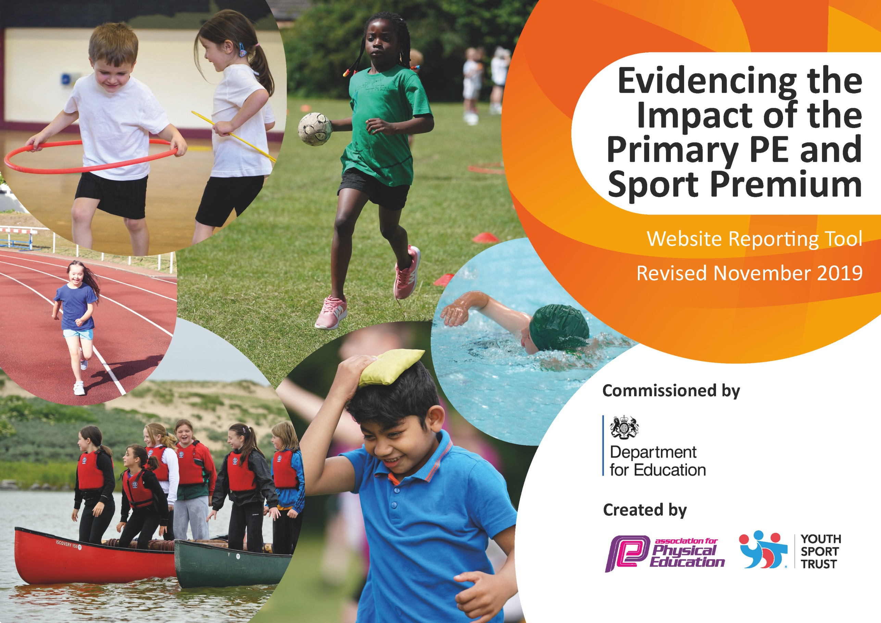
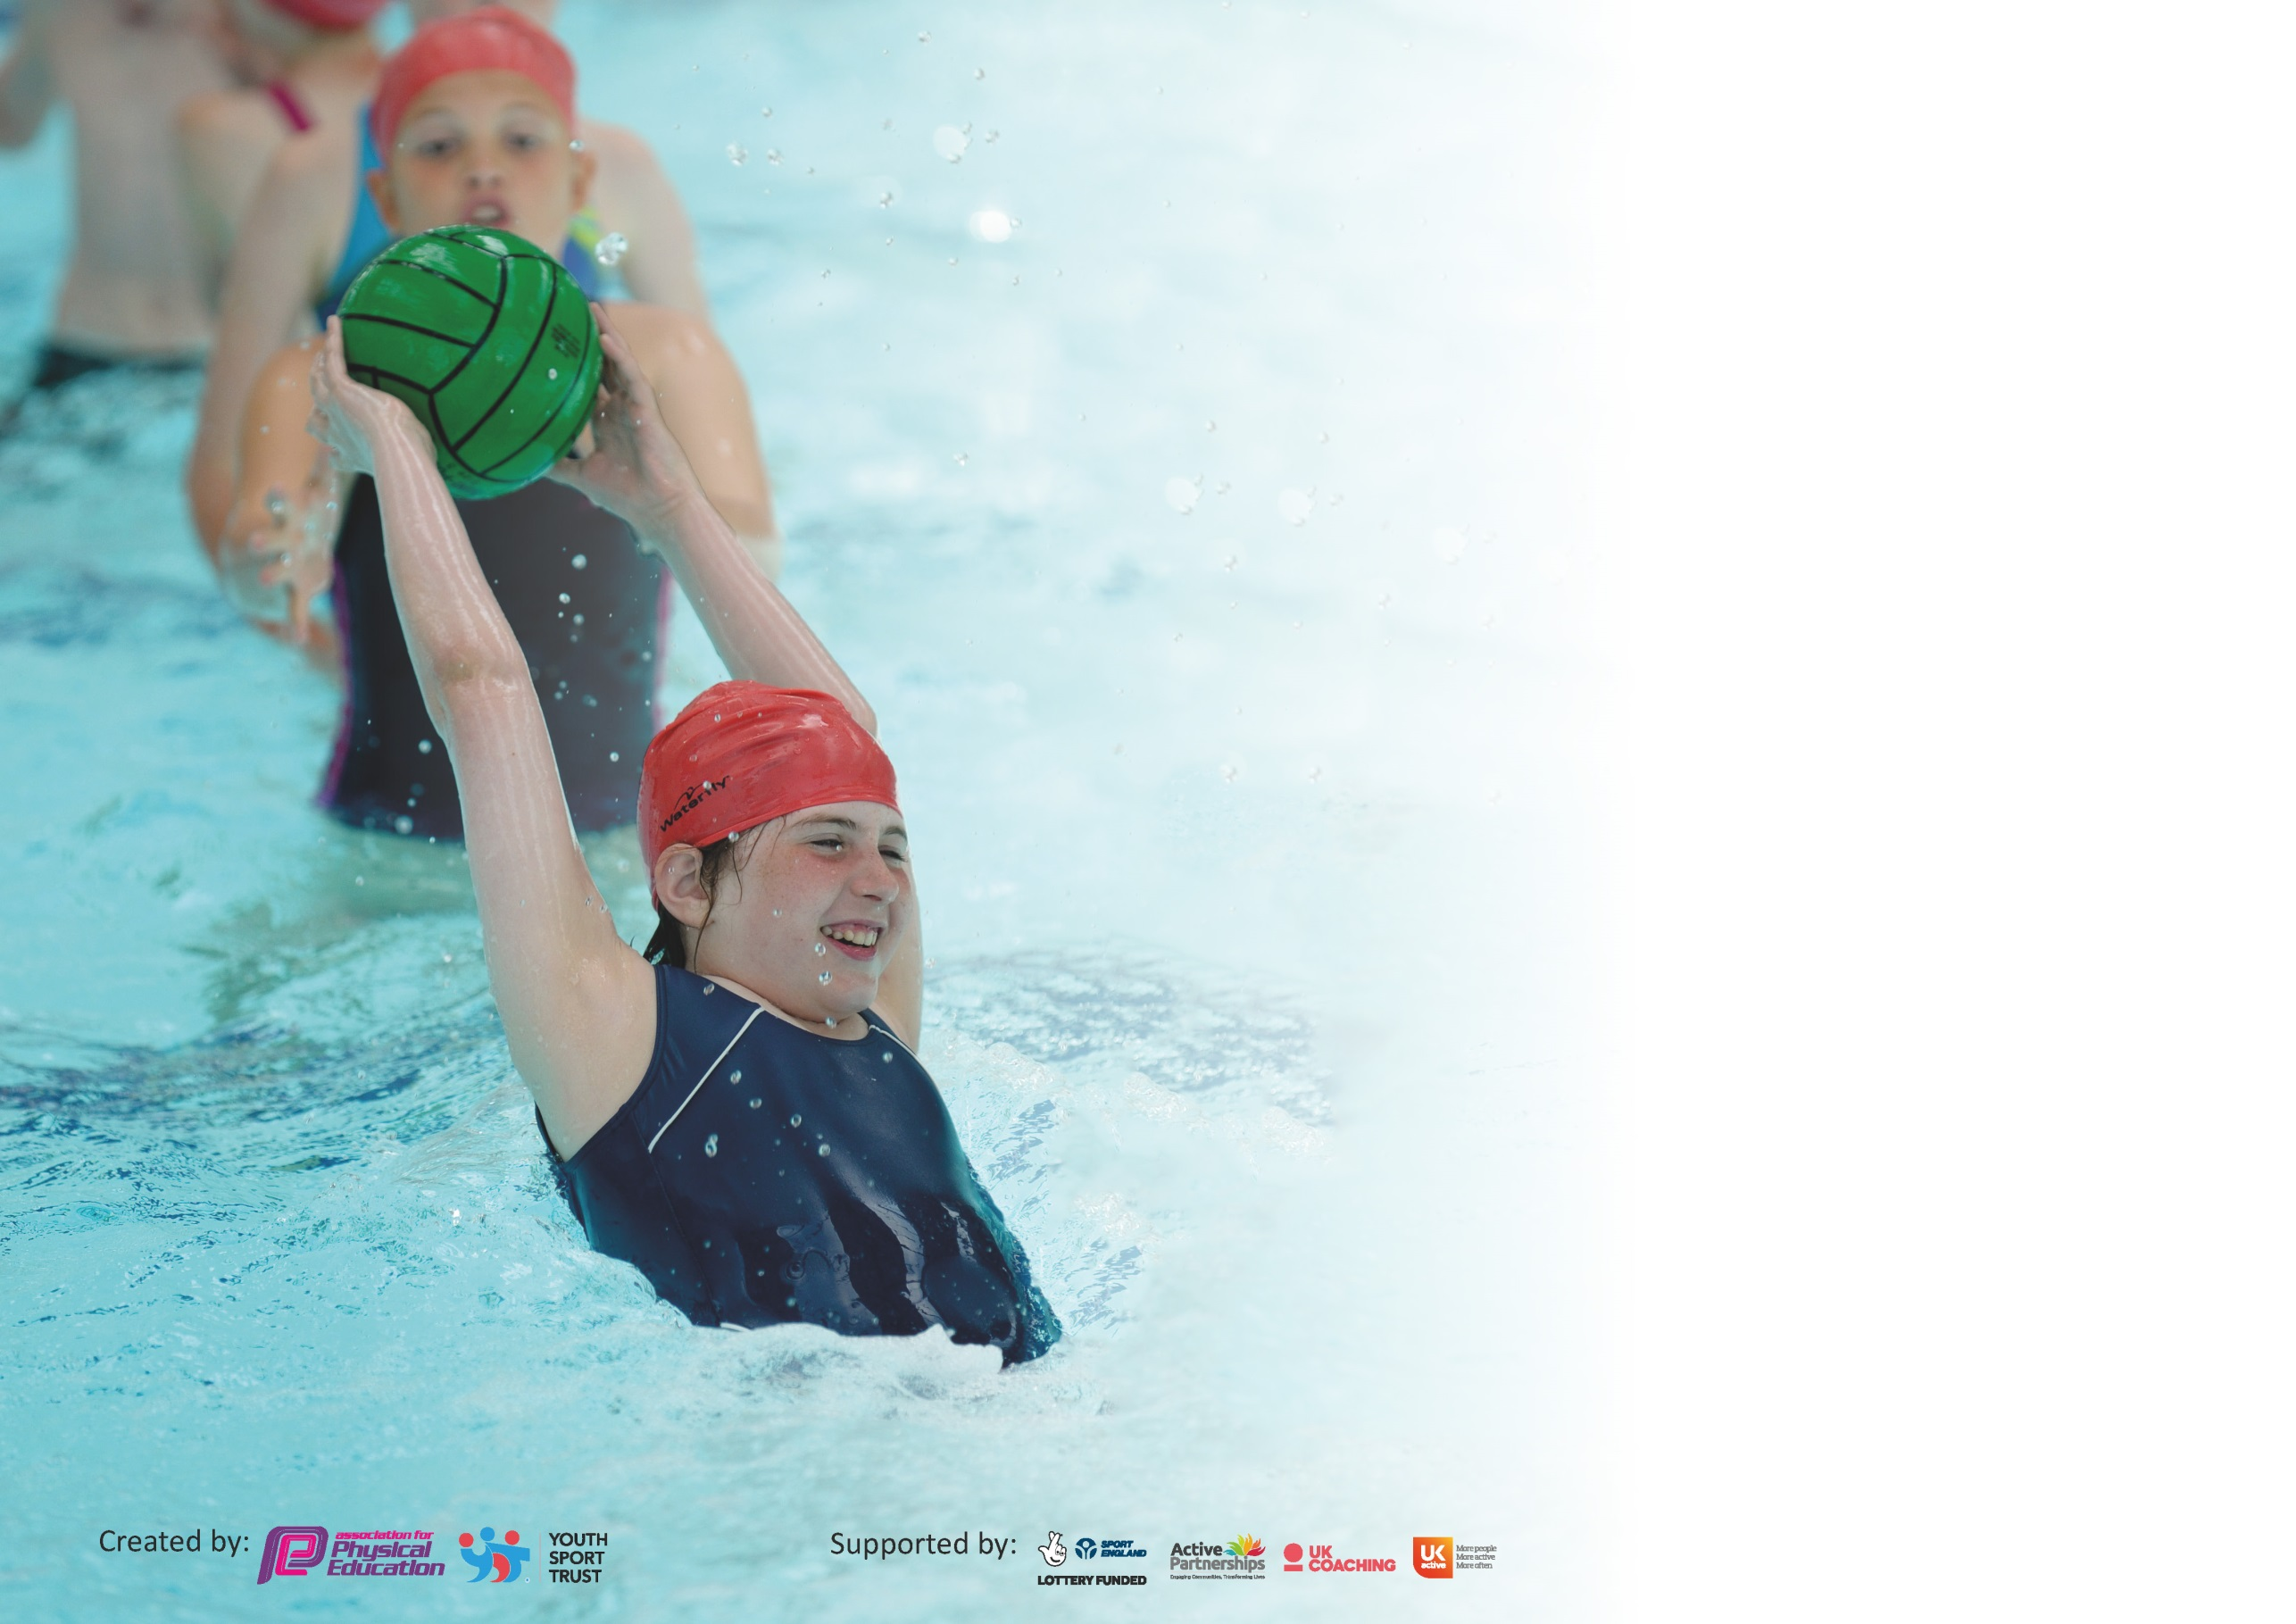

It is important that your grant is used effectively and based on school need. The Education Inspection Framework (Ofsted 2019 p64) makes clear there will be a focus on ‘whether leaders and those responsible for governors all understand their respective roles and perform these in a way that enhances the effectiveness of the school’.

Under the Quality of Education criteria (p41) inspectors consider the extent to which schools can articulate their curriculum (INTENT), construct their curriculum (IMPLEMENTATION) and demonstrate the outcomes which result (IMPACT).

To assist schools with common transferable language this template has been developed to utilise the same three headings which should make your plans easily transferable between working documents.

Schools must use the funding to make additional and sustainable improvements to the quality of Physical Education, School Sport and Physical Activity (PESSPA) they offer. This means that you should
use the Primary PE and Sport Premium to:

- Develop or add to the PESSPA activities that your school already offer
- Build capacity and capability within the school to ensure that improvements made now will benefit pupils joining the school in future years

Please visit gov.uk for the revised DfE guidance including the 5 key indicators across which schools should demonstrate an improvement. This document will help you to review your provision and to report your spend. DfE encourages schools to use this template as an effective way of meeting the reporting requirements of the Primary PE and Sport Premium.

We recommend you start by reflecting on the impact of current provision and reviewing the previous spend.

Schools are required to publish details of how they spend this funding as well as on the impact it has on pupils’ PE and sport participation and attainment by the end of the summer term or by 31st July 2020 at the latest.

We recommend regularly updating the table and publishing it on your website throughout the year. This evidences your ongoing self-evaluation of how you are using the funding to secure maximum, sustainable impact. Final copy must be posted on your website by the end of the academic year and no later than the 31st July 2020. To see an example of how to complete the table please click HERE.

Meeting national curriculum requirements for swimming and water safety.
What percentage of your current Year 6 cohort swim competently, confidently and proficiently over a distance of at least 25 metres?  N.B. Even though your pupils may swim in another year please report on their attainment on leaving  primary school at the end of the summer term 2020. | 88%
What percentage of your current Year 6 cohort use a range of strokes effectively [for example, front crawl, backstroke and breaststroke]? | 79%
What percentage of your current Year 6 cohort perform safe self-rescue in different water-based situations? | 79%
Schools can choose to use the Primary PE and Sport Premium to provide additional provision for swimming but this must be for activity over and above the national curriculum requirements. Have you used it in this way? | Yes, top up swimming - £291

Action Plan and Budget Tracking
Capture your intended annual spend against the 5 key indicators. Clarify the success criteria and evidence of impact that you intend to measure to evaluate for pupils today and for the future.

Academic Year: 2019/20 | Total fund allocated: £ | Date Updated:
Key indicator 1: The engagement of all pupils in regular physical activity – Chief Medical Officer guidelines recommend that primary school pupils undertake at least 30 minutes of physical activity a day in school |  |  |  |  | Percentage of total allocation:
 |  |  |  |  | %
Intent | Implementation |  | Impact
Encourage children and their families to be physically active using the Olympics Get Set Travel to Tokyo initiative.  To make it easier and more accessible for families to enjoy physical activity and sport together.  Boost girls enjoyment of and involvement in physical activity through ‘Girls Active Stepping Up for Change’ YST programme  Increase pupil participation in physical activity and raise confidence through ‘Change 4 Life’ Club  Attend NOSSP festivals targeted at the least active and least confident  Boost activity during break and lunchtimes. | Classes to log physical activity on the online activity tracker.  Create a display to encourage participation and create a competition.  Identify families who would benefit from taking part in the FAST programme which will include –  • 10 week family programme in all Primary Schools in the four wards • FREE locally-based activity sessions in parks and community centres • FREE FAST card with heavily reduced local offers • Resource packs and equipment to help families continue their favourite activities in their own time.  6 Y6 girls to attend YST Girls Active Leadership Training day.  Identify potential barriers to enjoyment of and participation in physical activity through Girls Active survey.  Girls Active Leaders to run a lunchtime club with mentor support boosting physical activity and addressing any issues that were revealed in the survey  Autumn Term  Conduct survey to identify -  - least active children  - children who have negative attitude towards physical activity  - children who lack confidence in PE  Spring Term  Run a KS2 C4L Club promoting the benefits of physical activity, supporting social skills and raising confidence. C4L Champions to support the running of the club  Identified girls to attend -  ‘This Girl Can’ festival  Identified children to attend C4L Festival  Purchase football goals x 4 for KS2 field and 2 additional goals for KS1 field  Mentor to attend ‘Active Leaders’ online guided learning course.  Run playground leadership training during Summer Term for Y5 children in preparation for Y6. | Mentor  (£10,721.91)  organised and overseen  Free but facilitated  through NOSSP affiliation (£2000)  NOSSP + Mentor  Mentor  NOSSP  NOSSP  £203 (+£500 legacy leisure grant)  NOSSP | All classes participated. Evidence of lots of family activity with many hours being logged.  11 families invited to attend with an average of 5 attending each week. Families enjoyed the range of activities and several have accessed locally based activity session at Woodgreen and Spiceball.  Leaders gained the skills needed to run a highly successful club which was attended by an average of 26 Y3/4 girls each week. Issues that came up on the survey were addressed which resulted in more positive attitudes towards physical activity and children being happier to join in (eg. getting hot and sweaty is a good thing, winning isn’t the most important thing))  Children identified but Club not run due to COVID 19 lockdown  10 Y5/6 girls attended the festival. Girls now more confident to attend inter-school events and take part in different activities.  12 Y3/4 attended an orienteering festival with 6 other schools. Confidence boosted by attendance.  More children able to play football during break and lunchtimes.  ‘Active Leaders’ course attended and qualification gained. Unfortunately Y5 training did not go ahead due to COVID 19. |  | Take part in Travel to Tokyo 2021. KS2 sports representatives to log activity for class first thing in the morning.  It is hoped that these families will access physical activity in the community using their FAST card and that they will form healthy habits for life. We would like the opportunity to take part in the programme again next year.  Leaders take their skills with them to secondary school and become part of Leadership Academies. Girls enhanced enjoyment and involvement in PESSPA will continue. Encourage the girls to become future Girls Active leaders  Complete in house Girls Active training next year to continue the initiative.  New leaders to choose and purchase equipment for the club with £200 grant.  Run a C4L club for these children next year.  Participate in TGC festival next year.  Participate in C4L festival next year. Some of the children will become C4L champions, leading club activities.  Goals are robust and will remain on the fields for the children to use. Introduce students led House football competitions.  Run playground leadership training for Y5 Summer Term 2021
Key indicator 2: The profile of PESSPA being raised across the school as a tool for whole school improvement |  |  |  |  | Percentage of total allocation:
 |  |  |  |  | %
Intent | Implementation |  |  | Impact
Identify and target pupils with behaviour/social/emotional needs and implement physical activity interventions targeting identified needs during the school day  Raise the profile of PESSPA within the school community through effective communication of events and achievements | Target children for -  EYFS/KS1 ‘Bee Bots’ – support settling in/working together as well as developing FMS  KS2 boys ‘Collaboration Club’ – development of interpersonal skills  KS2 girls ‘This Girl Can’ – development of self-esteem and self-confidence  Y3/4 boys ‘This Boy Can’ – boosting boys self-esteem and self-confidence  Identify specific needs of each child through student and teacher questionnaire  Focus on specific needs throughout interventions  Display/post PESSPA news on notice boards/FB/newsletter | Mentor  Mentor |  | Positive impact on identified specific needs and overriding objectives noted by Mentor  Pupil feedback gathered through questionnaires and indicates positive impact on identified needs  News displayed/posted regularly | Continue with interventions next year – matching the interventions with need  Involve the school newspaper journalists more in this.

Key indicator 3: Increased confidence, knowledge and skills of all staff in teaching PE and sport |  |  |  | Percentage of total allocation:
 |  |  |  | %
Intent | Implementation |  | Impact
Increase NQTs confidence, knowledge and skills in teaching PE  Develop staff confidence and competence by modelling good practice and providing support with the content, structure and delivery of PE lessons  Update PE Curriculum to enhance the delivery of high quality PE –  Vision  Curriculum map and SOW  Assessment  Ensure that staff have access to quality equipment to facilitate the delivery high quality PESPA  Develop ability to deliver age appropriate netball  Develop teacher confidence, knowledge and skills to deliver yoga during curriculum time and extra-curricular. | NQTs attend Primary Physical Education and Strategies for High Quality Teaching and Learning course including the key ingredients that make a good PE lesson, including: lesson structure, differentiation and the importance of physical literacy  Mentor to work alongside Y1/2 staff for delivery of multi-skills throughout the year.  Youth Activators to deliver games sessions for EYFS and Y1/2 – staff to assist and gain games ideas  Complete a 20+ hour online guided learning course - Physical  Education Curriculum Design and Implementation  - Re-write PE vision, circulate and design a student facing version for display.  - Create a curriculum map that incorporates Healthy Me, Social Me, Thinking Me as well as the physical – circulate and display  - Organise resources for each unit that teachers can easily access  - Create a simple method of assessment  Repair/replace/top up equipment as needed –  New equipment purchased:  Stopwatches  Low compression tennis balls  Vortex howlers  Foam javelins  Footballs  Netballs  Rugby balls  Urchin balls  Rubber balls  Sponge tennis balls  Hoops  Junior spring board  Crash mat  Vaulting box  Purchase ‘Bee Netball’ resource pack and share with relevant staff  Y3/4 teacher to complete online ‘Cosmic Kids’ foundation course in kids yoga teaching. | NOSSP  Mentor  £100  NOSSP + Mentor  £1989.44 + £136.76  £40.78  £200 | The delivery of high quality PE lessons.  The delivery of high quality PE lessons.  Rolled forward to 2020/2021 due to COVID 19.  Updated curriculum and resources will be introduced September  2020.  Staff have access to equipment in order to deliver high quality PE lessons. Break, lunchtime, activity breaks, clubs etc. are also well resourced and therefore facilitate higher quality activity and sport.  Resources shared and used during KS2 games lessons.  Course enrolled on and started – aim to complete by September 2020 to become qualified yoga teacher. | Upskilled staff. Attendees share main aspects of the course with colleagues.  Upskilled staff  Re-book for 2020/2021  Reflect and refine at the end of each unit.  Equipment sustainable  Bee Resources accessible for all staff. Make copies for playground leaders to use.  Delivery of high quality yoga lessons across Y3/4. Run an after school yoga club.
Key indicator 4: Broader experience of a range of sports and activities offered to all pupils |  |  |  | Percentage of total allocation:
 |  |  |  | %
Intent | Implementation |  | Impact
To make it easier and more accessible for families to enjoy physical activity and sport together.  Create more opportunities for Y5/6 to play sport during lunchtime  Create more opportunities for Y1/2 and Y3/4 to play games during lunchtime. | Identify families who would benefit from taking part in the FAST programme which includes –  • FREE 10 week family programme with a different activity each week• FREE locally-based activity sessions in parks and community centres • FREE FAST card with heavily reduced local offers • Resource packs and equipment to help families continue their favourite activities in their own time.  Introduce lunchtime club on a Wednesday –  Autumn Term = Netball  Spring Term = Hockey  Summer Term = Tennis  Introduce ‘Youth Activator’ Sessions during Term 5 for Y1/2 and Term 6 for Y3/4. Children will be on a rota so all will benefit. | NOSSP affiliation  Mentor  (£100) | 11 families invited to attend with an average of 5 attending each week. Families enjoyed the range of activities and several have accessed locally based activity session at Woodgreen and Spiceball.  Successful netball club run during Autumn Term with 20 children regularly attending. Vast improvement in their skills and understanding of the game. Some children participated in NOSSP netball tournament and finished in 2nd place qualifying for finals (cancelled due to COVID)  These sessions were paid for but did not go ahead due to COVID 19. We plan to roll them forward to 2020/2021 | Request to take part 2020/2021  Ensure that all Y6 have opportunity to participate in at least 1 term if they want to.  Re-organise

Key indicator 5: Increased participation in competitive sport |  |  |  | Percentage of total allocation:
 |  |  |  | %
Intent | Implementation |  | Impact
Children to experience an inter-school competition/festival | Attend NOSSP events + Wade Gymnastics Club competitions  Track children’s participation to ensure as many participate as possible | NOSSP affiliation  £105+£150 | Maximum amount of children entered into festivals/competitions up to lockdown. | Use tracking system to ensure that all Y1-6 attend at least 1 event/festival

2019-20 FY Allocation Sept-March | £10,920  Signed off by  Head Teacher:  Date:  Subject Leader:  Date:  Governor:  Date:
2020-21 FY Allocation Apr - Aug | £7,800
2019/20 AY Allocation | £18,720
Legacy Leisure Grant | £500
Youth Sports Trust Grant – Girls Active | £200
Total Funding Available | £19,420
Funding spent | £16,437.89
Funding remaining (due to COVID 19) | £2982.11

